**FLOOD MONITORING AND EARLY WARNING**

**INTRODUCTION**

Flood contributes to significant danger in life and property damage in many areas over the world. In Malaysia, monsoonal flood and flash flood occur respectively during the northeast monsoon and heavy rains causing the loss of life and property damages. Flood is one of the most common natural disasters that Malaysia faced annually. Based on data collected by the Centre for Public Policies Studies, due to climate change, rainfall in Malaysia is above average especially during monsoons seasons affecting cities particularly in the eastern states such as Kelantan, Terengganu, and Perak. However, urban cities with rapid growth like Kuala Lumpur also face this problem due to the inefficiency of the drainage systems. In 2009, researchers have found that an estimation of the area at risk of flooding is approximately 29,800km2 that is about 9% of the total area in Malaysia affecting almost 4.85 million people, which is approximately 22% of the total population in this country

**ABSTRACT**

Flood monitoring and early warning systems play a pivotal role in safeguarding communities from the devastating impacts of floods. These systems integrate advanced technology, including weather forecasting, river level sensors, and satellite imagery, to continuously monitor environmental conditions. When a potential flood risk is detected, timely alerts are disseminated to authorities and the public through various communication channels, such as mobile apps, sirens, and social media. These warnings not only provide crucial lead time for evacuation and emergency response but also enable communities to take preventive measures, such as reinforcing flood defenses and securing valuable assets. Flood monitoring and early warning systems are essential tools in mitigating the loss of life and property, promoting resilience, and ensuring that communities are better prepared to face the increasing challenges posed by climate change and rising sea levelsData from these sources are analyzed in real-time by meteorologists and hydrologists to assess the likelihood of flooding. When a potential flood risk is identified, early warning messages are disseminated through various communication channels, including mobile alerts, sirens, and television broadcasts, to alert residents in affected areas.. This timely information empowers communities to take precautionary measures such as evacuating to safer locations, moving valuable assets to higher ground, and implementing flood-resistant infrastructure. By providing advance notice, flood monitoring and early warning systems save lives and mitigate economic losses associated with flooding, making them essential tools in disaster preparedness and response.

**DESIGN**

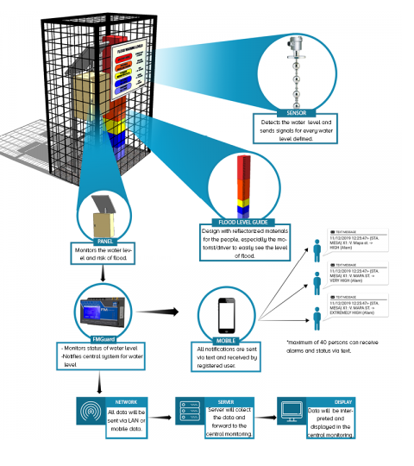

**FLOOD SENSOR**

Flood sensors are crucial devices designed to detect and monitor water levels in various environments. These sensors employ a range of technologies, including ultrasonic, pressure, or moisture-based systems, to continuously assess water levels and potential flooding risks. When a flood sensor detects rising water levels, it triggers alarms or alerts, providing early warning to individuals, communities, or authorities. This proactive approach helps mitigate the devastating effects of floods by allowing timely evacuation, safeguarding property, and potentially saving lives. Moreover, flood sensors are increasingly integrated into smart home and IoT systems, offering homeowners real-time monitoring and peace of mind, contributing to improved disaster preparedness and resilience in flood-prone regions.

**RELATED IMAGES**

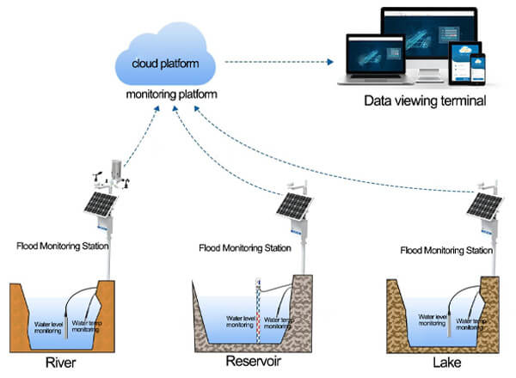

**CONCLUSION**

In conclusion, flood monitoring and early warning systems play a pivotal role in mitigating the devastating impact of floods on both human lives and infrastructure. These systems employ advanced technology and data analysis to provide timely alerts, giving communities crucial time to prepare and evacuate if necessary. As climate change continues to increase the frequency and severity of floods*,* the importance of investing in and improving these monitoring and warning systems cannot be overstated. By embracing innovation and collaboration, we can work towards a future where flood-related disasters are minimized, and lives are saved

***THANK YOU***